Chapter 01
An Introduction to Business Statistics

True / False Questions
1. | A population is a set of existing units.  True False

2. | If we examine some of the population measurements, we are conducting a census of the population.  True False

3. | A random sample is selected so that every element in the population has the same chance of being included in the sample.  True False

4. | An example of a quantitative variable is the manufacturer of a car.  True False

5. | An example of a qualitative variable is the mileage of a car.  True False

6. | Statistical inference is the science of using a sample of measurements to make generalizations about the important aspects of a population of measurements.  True False

7. | Time series data are data collected at the same time period.  True False

8. | Cross-sectional data are data collected at the same point in time.  True False

9. | Daily temperature in a local community collected over a 30-day time period is an example of cross-sectional data.  True False

10. | The number of sick days taken by employees in 2008 for the top 10 technology companies is an example of time series data.  True False

11. | The number of sick days per month taken by employees for the last 10 years at Apex Co. is an example of time series data.  True False

12. | A quantitative variable can also be referred to as a categorical variable.  True False

13. | In a data set of information on college business students, an example of an element is their cumulative GPA.  True False

14. | In an observational study, the variable of interest is called a response variable.  True False

15. | In an experimental study, the aim is to manipulate or set the value of the response variable.  True False

16. | The science of describing the important aspects of a set of measures is called statistical inference.  True False

17. | It is possible to use a random sample from one population to make statistical inferences about another related population.  True False

18. | Processes produce outputs over time.  True False

19. | Selecting many different samples and running many different tests can eventually produce a result that makes a desired conclusion seem to be true when the conclusion is true.  True False

20. | Using a nonrandom sample procedure in order to support a desired conclusion is an example of an unethical statistical procedure.  True False

Multiple Choice Questions
21. | A ratio variable has the following characteristic:  A. Meaningful order  B. Inherently defined zero value  C. Categorical in nature  D. Predictable

22. | Which of the following is a quantitative variable?  A. The manufacturer of a cell phone  B. A person's gender  C. Mileage of a car  D. Whether a person is a college graduate  E. Whether a person has a charge account

23. | Which of the following is a categorical variable?  A. Air temperature  B. Bank account balance  C. Daily sales in a store  D. Whether a person has a traffic violation  E. Value of company stock

24. | Measurements from a population are called  A. Elements.  B. Observations.  C. Variables.  D. Processes.

25. | The two types of quantitative variables are:  A. Ordinal and ratio  B. Interval and ordinal  C. Nominative and ordinal  D. Interval and ratio  E. Nominative and interval

26. | Temperature (in degrees Fahrenheit) is an example of a(n) __________ variable.  A. Nominative  B. Ordinal  C. Interval  D. Ratio

27. | Jersey numbers of soccer players is an example of a(n) ___________ variable.  A. Nominative  B. Ordinal  C. Interval  D. Ratio

28. | The weight of a chemical compound used in an experiment that is obtained using a well-adjusted scale represents a(n) _____________ level of measurement.  A. Nominative  B. Ordinal  C. Interval  D. Ratio

29. | An identification of police officers by rank would represent a(n) ____________ level of measurement.  A. Nominative  B. Ordinal  C. Interval  D. Ratio

30. | __________ is a necessary component of a runs plot.  A. Observation over time  B. Qualitative variable  C. Random sampling of the data  D. Cross-sectional data

31. | ______________ is the science of using a sample to make generalizations about the important aspects of a population.  A. Time series analysis  B. Descriptive statistics  C. Random sample  D. Statistical inference

32. | College entrance exam scores, such as SAT scores, are an example of a(n) _____________ variable.  A. Ordinal  B. Ratio  C. Nominative  D. Interval

33. | The number of miles a truck is driven before it is overhauled is an example of a(n) _____________ variable.  A. Nominative  B. Ordinal  C. Interval  D. Ratio

34. | A(n) _____________ variable is a qualitative variable such that there is no meaningful ordering or ranking of the categories.  A. Ratio  B. Ordinal  C. Nominative  D. Interval

35. | A person's telephone area code is an example of a(n) _____________ variable.  A. Nominative  B. Ordinal  C. Interval  D. Ratio

36. | Any characteristic of a population unit is a(n):  A. Measurement  B. Sample  C. Observation  D. Variable

37. | Examining all population measurements is called a _____________.  A. Census  B. Frame  C. Sample  D. Variable

38. | Any characteristic of an element is called a ____________.  A. Set  B. Process  C. Variable  D. Census

39. | The process of assigning a value of a variable to each element in a data set is called ___________.  A. Sampling  B. Measurement  C. Experimental analysis  D. Observational analysis

40. | A ___________ is a display of individual measurements versus time.  A. Runs plot  B. Statistical analysis  C. Random sample  D. Measurement

41. | Statistical ____________ refers to using a sample of measurements and making generalizations about the important aspects of a population.  A. Sampling  B. Process  C. Analysis  D. Inference

42. | A ____________ is a subset of the units in a population.  A. Census  B. Process  C. Sample  D. Variable

43. | A ____________ variable can have values that are numbers on the real number line.  A. Qualitative  B. Quantitative  C. Categorical  D. Nominative

44. | A sequence of operations that takes inputs and turns them into outputs is a ____________.  A. Process  B. Statistical inference  C. Runs plot  D. Random sampling

45. | A(n) ____________ variable can have values that indicate into which of several categories of a population it belongs.  A. Qualitative  B. Quantitative  C. Ratio  D. Interval

46. | A set of all elements we wish to study is called a ____________.  A. Sample  B. Process  C. Census  D. Population

47. | ___________ refers to describing the important aspects of a set of measurements.  A. Cross-sectional analysis  B. Runs plot  C. Descriptive statistics  D. Time series analysis

48. | The change in the daily price of a stock is what type of variable?  A. Qualitative  B. Ordinal  C. Random  D. Quantitative

49. | Data collected for a particular study are referred to as a data ____________.  A. Variable  B. Measurement  C. Set  D. Element

50. | A data set provides information about some group of individual _____________.  A. Variables  B. Elements  C. Statistics  D. Measurements

51. | When the data being studied are gathered from a private source, this is referred to as a(n) _______________.  A. Existing data source  B. Observational data source  C. Experimental data source  D. Cross-sectional data source

52. | One method of determining whether a sample being studied can be used to make statistical inferences about the population is to:  A. Run a descriptive statistical analysis  B. Calculate a proportion  C. Create a cross-sectional data analysis  D. Produce a runs plot

53. | Which of the following is NOT an example of unethical statistical practices?  A. Inappropriate interpretation of statistical results  B. Using graphs to make statistical inferences  C. Improper sampling  D. Descriptive measures that mislead the user  E. None of these

54. | If we collect data on the number of wins each team in the NFL had during the 2011-12 season, we have _____________ data.  A. Cross-sectional  B. Time series

55. | If we collect data on the number of wins the Dallas Cowboys earned each of the past 10 years, we have _____________ data.  A. Cross-sectional  B. Time series

Essay Questions
56. | A study is being conducted on the effect of gas price on the number of miles driven in a given month. Residents in two cities, one on the East Coast and one on the West Coast are randomly selected and asked to complete a questionnaire on the type of car they drive, the number of miles they live from work, the number of children under 18 in their household, their monthly income, and the number of miles they have driven over the past 30 days. List the response variable(s).

57. | A study is being conducted on the effect of gas price on the number of miles driven in a given month. Residents in two cities, one on the East Coast and one on the West Coast are randomly selected and asked to complete a questionnaire on the type of car they drive, the number of miles they live from work, the number of children under 18 in their household, their monthly income, and the number of miles they have driven over the past 30 days. Is this an experimental or observational study?

58. | A study is being conducted on the effect of gas price on the number of miles driven in a given month. Residents in two cities, one on the East Coast and one on the West Coast are randomly selected and asked to complete a questionnaire on the type of car they drive, the number of miles they live from work, the number of children under 18 in their household, their monthly income, and the number of miles they have driven over the past 30 days. List the factor(s).

59. | Looking at the runs plot of gasoline prices over the past 30 months, describe what it tells us about the price of gas during these 30 months.  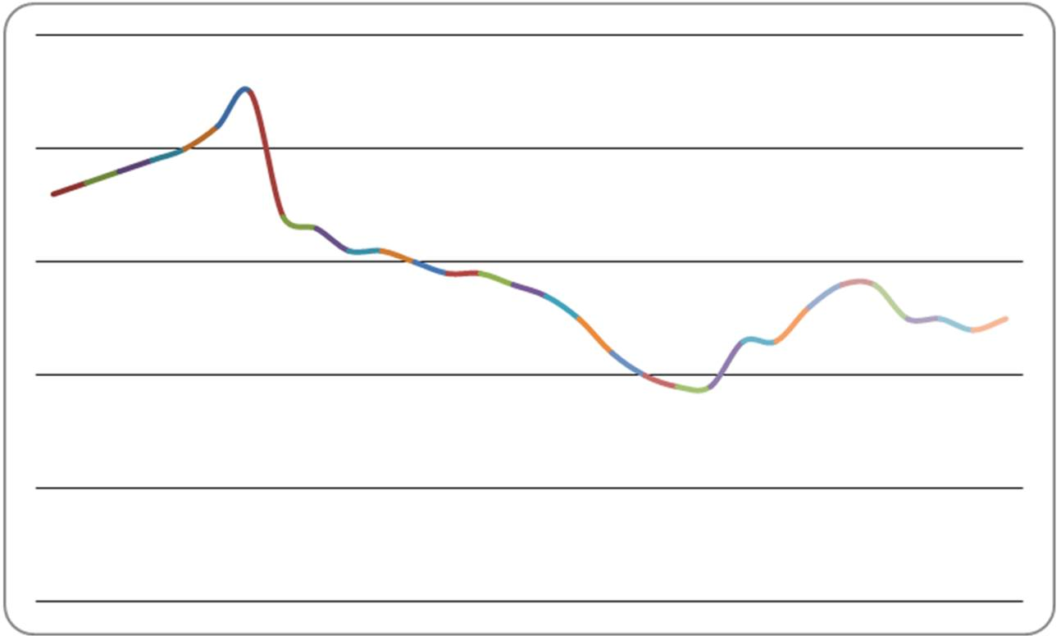

60. | Using the following data table of the average hours per week spent on Internet activities by 15- to 18-year-olds for the years 1999-2008, construct the runs plot and interpret.  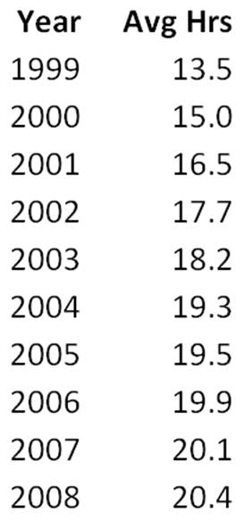

Chapter 01 An Introduction to Business Statistics Answer Key

True / False Questions
1. | A population is a set of existing units.  TRUE

AACSB: Reflective Thinking
Blooms: Remember
Difficulty: 1 Easy
Learning Objective: 01-06 Describe the difference between a population and a sample.
Topic: Population

2. | If we examine some of the population measurements, we are conducting a census of the population.  FALSE  A census is defined as examining all of the population measurements.

AACSB: Reflective Thinking
Blooms: Understand
Difficulty: 2 Medium
Learning Objective: 01-06 Describe the difference between a population and a sample.
Topic: Population

3. | A random sample is selected so that every element in the population has the same chance of being included in the sample.  TRUE

AACSB: Reflective Thinking
Blooms: Remember
Difficulty: 1 Easy
Learning Objective: 01-08 Explain the importance of random sampling.
Topic: Random Sampling

4. | An example of a quantitative variable is the manufacturer of a car.  FALSE  This is an example of a qualitative or categorical variable.

AACSB: Reflective Thinking
Blooms: Understand
Difficulty: 1 Easy
Learning Objective: 01-02 Describe the difference between a quantitative and a qualitative variable.
Topic: Variable

5. | An example of a qualitative variable is the mileage of a car.  FALSE  This is an example of a quantitative variable.

AACSB: Reflective Thinking
Blooms: Understand
Difficulty: 1 Easy
Learning Objective: 01-02 Describe the difference between a quantitative and a qualitative variable.
Topic: Variable

6. | Statistical inference is the science of using a sample of measurements to make generalizations about the important aspects of a population of measurements.  TRUE

AACSB: Reflective Thinking
Blooms: Remember
Difficulty: 2 Medium
Learning Objective: 01-07 Distinguish between descriptive statistics and statistical inference.
Topic: Sample

7. | Time series data are data collected at the same time period.  FALSE  Time series data are collected over different time periods.

AACSB: Reflective Thinking
Blooms: Remember
Difficulty: 1 Easy
Learning Objective: 01-03 Describe the difference between cross-sectional data and time series data.
Topic: Time Series Data

8. | Cross-sectional data are data collected at the same point in time.  TRUE

AACSB: Reflective Thinking
Blooms: Remember
Difficulty: 1 Easy
Learning Objective: 01-03 Describe the difference between cross-sectional data and time series data.
Topic: Cross-Sectional Data

9. | Daily temperature in a local community collected over a 30-day time period is an example of cross-sectional data.  FALSE  Cross-sectional data are collected at the same point in time. This is an example of time series data.

AACSB: Reflective Thinking
Blooms: Understand
Difficulty: 1 Easy
Learning Objective: 01-03 Describe the difference between cross-sectional data and time series data.
Topic: Cross-Sectional Data

10. | The number of sick days taken by employees in 2008 for the top 10 technology companies is an example of time series data.  FALSE  This is an example of cross-sectional data. Time series data are collected at different time periods.

AACSB: Reflective Thinking
Blooms: Understand
Difficulty: 1 Easy
Learning Objective: 01-03 Describe the difference between cross-sectional data and time series data.
Topic: Time Series Data

11. | The number of sick days per month taken by employees for the last 10 years at Apex Co. is an example of time series data.  TRUE

AACSB: Reflective Thinking
Blooms: Understand
Difficulty: 2 Medium
Learning Objective: 01-03 Describe the difference between cross-sectional data and time series data.
Topic: Time Series Data

12. | A quantitative variable can also be referred to as a categorical variable.  FALSE  Qualitative variables are also known as categorical variables.

AACSB: Reflective Thinking
Blooms: Understand
Difficulty: 1 Easy
Learning Objective: 01-02 Describe the difference between a quantitative and a qualitative variable.
Topic: Quantitative Variable

13. | In a data set of information on college business students, an example of an element is their cumulative GPA.  FALSE  The element is college business students. The cumulative GPA is an example of a variable, which is a characteristic of the element college business students.

AACSB: Reflective Thinking
Blooms: Understand
Difficulty: 2 Medium
Learning Objective: 01-01 Explain what a variable is.
Topic: Data

14. | In an observational study, the variable of interest is called a response variable.  TRUE

AACSB: Reflective Thinking
Blooms: Remember
Difficulty: 1 Easy
Learning Objective: 01-05 Identify the different types of data sources: existing data sources; experimental studies; and observational studies.
Topic: Data Sources

15. | In an experimental study, the aim is to manipulate or set the value of the response variable.  FALSE  In experimental studies, the aim is to manipulate the factor, which is related to the response variable.

AACSB: Reflective Thinking
Blooms: Understand
Difficulty: 2 Medium
Learning Objective: 01-05 Identify the different types of data sources: existing data sources; experimental studies; and observational studies.
Topic: Data Sources

16. | The science of describing the important aspects of a set of measures is called statistical inference.  FALSE  This is the definition of descriptive statistics. Statistical inference is the science of using a sample of measurements to make generalizations about the population of measurements.

AACSB: Reflective Thinking
Blooms: Understand
Difficulty: 2 Medium
Learning Objective: 01-07 Distinguish between descriptive statistics and statistical inference.
Topic: Statistical Inference

17. | It is possible to use a random sample from one population to make statistical inferences about another related population.  TRUE

AACSB: Reflective Thinking
Blooms: Understand
Difficulty: 2 Medium
Learning Objective: 01-08 Explain the importance of random sampling.
Topic: Random Sampling

18. | Processes produce outputs over time.  TRUE

AACSB: Reflective Thinking
Blooms: Remember
Difficulty: 1 Easy
Learning Objective: 01-08 Explain the importance of random sampling.
Topic: Process

19. | Selecting many different samples and running many different tests can eventually produce a result that makes a desired conclusion seem to be true when the conclusion is true.  FALSE  Using different samples and tests to produce a desired conclusion does not make the conclusion true.

AACSB: Ethics
Blooms: Understand
Difficulty: 2 Medium
Learning Objective: 01-08 Explain the importance of random sampling.
Topic: Ethical Guidelines

20. | Using a nonrandom sample procedure in order to support a desired conclusion is an example of an unethical statistical procedure.  TRUE

AACSB: Ethics
Blooms: Understand
Difficulty: 2 Medium
Learning Objective: 01-08 Explain the importance of random sampling.
Topic: Ethical Guidelines

Multiple Choice Questions
21. | A ratio variable has the following characteristic:  A. Meaningful order  B. Inherently defined zero value  C. Categorical in nature  D. Predictable  By definition, ratio variables are quantitative and have an absolute zero value.

AACSB: Reflective Thinking
Blooms: Understand
Difficulty: 1 Easy
Learning Objective: 01-09 Identify the ratio; interval; ordinal; and nominative scales of measurement.
Topic: Variable

22. | Which of the following is a quantitative variable?  A. The manufacturer of a cell phone  B. A person's gender  C. Mileage of a car  D. Whether a person is a college graduate  E. Whether a person has a charge account  A quantitative variable is measurable and noncategorical.

AACSB: Reflective Thinking
Blooms: Remember
Difficulty: 1 Easy
Learning Objective: 01-02 Describe the difference between a quantitative and a qualitative variable.
Topic: Variable

23. | Which of the following is a categorical variable?  A. Air temperature  B. Bank account balance  C. Daily sales in a store  D. Whether a person has a traffic violation  E. Value of company stock  A categorical variable is qualitative, not measured.

AACSB: Reflective Thinking
Blooms: Understand
Difficulty: 2 Medium
Learning Objective: 01-02 Describe the difference between a quantitative and a qualitative variable.
Topic: Variable

24. | Measurements from a population are called  A. Elements.  B. Observations.  C. Variables.  D. Processes.  By definition, elements and variables are the same; processes are not measurements.

AACSB: Reflective Thinking
Blooms: Understand
Difficulty: 2 Medium
Learning Objective: 01-06 Describe the difference between a population and a sample.
Topic: Population

25. | The two types of quantitative variables are:  A. Ordinal and ratio  B. Interval and ordinal  C. Nominative and ordinal  D. Interval and ratio  E. Nominative and interval  Nominative and ordinal are types of qualitative variables.

AACSB: Reflective Thinking
Blooms: Understand
Difficulty: 2 Medium
Learning Objective: 01-09 Identify the ratio; interval; ordinal; and nominative scales of measurement.
Topic: Variable

26. | Temperature (in degrees Fahrenheit) is an example of a(n) __________ variable.  A. Nominative  B. Ordinal  C. Interval  D. Ratio  Temperature is quantitative (excludes nominative and ordinal) and the ratio of two temperatures is not meaningful.

AACSB: Reflective Thinking
Blooms: Understand
Difficulty: 2 Medium
Learning Objective: 01-09 Identify the ratio; interval; ordinal; and nominative scales of measurement.
Topic: Variable

27. | Jersey numbers of soccer players is an example of a(n) ___________ variable.  A. Nominative  B. Ordinal  C. Interval  D. Ratio  Interval and ratio are quantitative variables; jersey numbers have no logical order.

AACSB: Reflective Thinking
Blooms: Understand
Difficulty: 2 Medium
Learning Objective: 01-09 Identify the ratio; interval; ordinal; and nominative scales of measurement.
Topic: Variable

28. | The weight of a chemical compound used in an experiment that is obtained using a well-adjusted scale represents a(n) _____________ level of measurement.  A. Nominative  B. Ordinal  C. Interval  D. Ratio  Nominative and ordinal are qualitative variables; weight creates logical ratios: 60 lbs is twice as heavy as 30 lbs.

AACSB: Reflective Thinking
Blooms: Understand
Difficulty: 2 Medium
Learning Objective: 01-09 Identify the ratio; interval; ordinal; and nominative scales of measurement.
Topic: Variable

29. | An identification of police officers by rank would represent a(n) ____________ level of measurement.  A. Nominative  B. Ordinal  C. Interval  D. Ratio  Interval and ratio are quantitative variables, nominative is only a naming category, and police rank has order.

AACSB: Reflective Thinking
Blooms: Understand
Difficulty: 2 Medium
Learning Objective: 01-09 Identify the ratio; interval; ordinal; and nominative scales of measurement.
Topic: Variable

30. | __________ is a necessary component of a runs plot.  A. Observation over time  B. Qualitative variable  C. Random sampling of the data  D. Cross-sectional data  A runs plot is a graphical display of time series data.

AACSB: Reflective Thinking
Blooms: Understand
Difficulty: 2 Medium
Learning Objective: 01-04 Construct and interpret a time series (runs) plot.
Topic: Time Series Data

31. | ______________ is the science of using a sample to make generalizations about the important aspects of a population.  A. Time series analysis  B. Descriptive statistics  C. Random sample  D. Statistical inference  By definition, a time series is a study of data over time; descriptive statistics is the study of the measurements of population variables; a random sample is a data set.

AACSB: Reflective Thinking
Blooms: Remember
Difficulty: 1 Easy
Learning Objective: 01-07 Distinguish between descriptive statistics and statistical inference.
Topic: Population

32. | College entrance exam scores, such as SAT scores, are an example of a(n) _____________ variable.  A. Ordinal  B. Ratio  C. Nominative  D. Interval  Nominative and ordinal are qualitative variables; exam scores have no meaningful ratio and no inherently defined zero value.

AACSB: Reflective Thinking
Blooms: Understand
Difficulty: 3 Hard
Learning Objective: 01-09 Identify the ratio; interval; ordinal; and nominative scales of measurement.
Topic: Variable

33. | The number of miles a truck is driven before it is overhauled is an example of a(n) _____________ variable.  A. Nominative  B. Ordinal  C. Interval  D. Ratio  Nominative and ordinal are qualitative variables; miles driven can have a meaningful ratio.

AACSB: Reflective Thinking
Blooms: Understand
Difficulty: 2 Medium
Learning Objective: 01-09 Identify the ratio; interval; ordinal; and nominative scales of measurement.
Topic: Variable

34. | A(n) _____________ variable is a qualitative variable such that there is no meaningful ordering or ranking of the categories.  A. Ratio  B. Ordinal  C. Nominative  D. Interval  Ratio and interval are quantitative variables; ordinal implies order or rank.

AACSB: Reflective Thinking
Blooms: Understand
Difficulty: 1 Easy
Learning Objective: 01-09 Identify the ratio; interval; ordinal; and nominative scales of measurement.
Topic: Variable

35. | A person's telephone area code is an example of a(n) _____________ variable.  A. Nominative  B. Ordinal  C. Interval  D. Ratio  This is a qualitative variable without order; therefore, a nominative variable.

AACSB: Reflective Thinking
Blooms: Understand
Difficulty: 2 Medium
Learning Objective: 01-09 Identify the ratio; interval; ordinal; and nominative scales of measurement.
Topic: Variable

36. | Any characteristic of a population unit is a(n):  A. Measurement  B. Sample  C. Observation  D. Variable  Measurement and observation are methods attached to a variable; a sample is a subset of the units in a population.

AACSB: Reflective Thinking
Blooms: Remember
Difficulty: 2 Medium
Learning Objective: 01-01 Explain what a variable is.
Topic: Variable

37. | Examining all population measurements is called a _____________.  A. Census  B. Frame  C. Sample  D. Variable  By definition, a census looks at the entire population.

AACSB: Reflective Thinking
Blooms: Remember
Difficulty: 2 Medium
Learning Objective: 01-06 Describe the difference between a population and a sample.
Topic: Population

38. | Any characteristic of an element is called a ____________.  A. Set  B. Process  C. Variable  D. Census  A process is a sequence of operations; a census looks at the entire population; set is related to population.

AACSB: Reflective Thinking
Blooms: Remember
Difficulty: 1 Easy
Learning Objective: 01-01 Explain what a variable is.
Topic: Population

39. | The process of assigning a value of a variable to each element in a data set is called ___________.  A. Sampling  B. Measurement  C. Experimental analysis  D. Observational analysis  By definition, sampling is taking a portion of the population to measure; experimental and observational analysis are methods of obtaining data.

AACSB: Reflective Thinking
Blooms: Understand
Difficulty: 2 Medium
Learning Objective: 01-01 Explain what a variable is.
Topic: Variable

40. | A ___________ is a display of individual measurements versus time.  A. Runs plot  B. Statistical analysis  C. Random sample  D. Measurement  A runs plot is a graphical display of data over time.

AACSB: Reflective Thinking
Blooms: Remember
Difficulty: 1 Easy
Learning Objective: 01-04 Construct and interpret a time series (runs) plot.
Topic: Time Series Data

41. | Statistical ____________ refers to using a sample of measurements and making generalizations about the important aspects of a population.  A. Sampling  B. Process  C. Analysis  D. Inference  By definition, inference is taking a sample of data and its measurements and relating those measurements to the population as a whole.

AACSB: Reflective Thinking
Blooms: Understand
Difficulty: 2 Medium
Learning Objective: 01-07 Distinguish between descriptive statistics and statistical inference.
Topic: Sample

42. | A ____________ is a subset of the units in a population.  A. Census  B. Process  C. Sample  D. Variable  By definition, a census looks at an entire population; a variable is a characteristic of an element within the population; a process is a sequence of operations that produces elements of a population.

AACSB: Reflective Thinking
Blooms: Remember
Difficulty: 1 Easy
Learning Objective: 01-06 Describe the difference between a population and a sample.
Topic: Sample

43. | A ____________ variable can have values that are numbers on the real number line.  A. Qualitative  B. Quantitative  C. Categorical  D. Nominative  Qualitative, categorical, and nominative have similar definitions.

AACSB: Reflective Thinking
Blooms: Understand
Difficulty: 2 Medium
Learning Objective: 01-02 Describe the difference between a quantitative and a qualitative variable.
Topic: Variable

44. | A sequence of operations that takes inputs and turns them into outputs is a ____________.  A. Process  B. Statistical inference  C. Runs plot  D. Random sampling  By definition, a runs plot is a graphical display; random sampling is a method of selecting a portion of a population; statistical inference is the science of using a sample of measurements to infer about the entire population.

AACSB: Reflective Thinking
Blooms: Remember
Difficulty: 1 Easy
Learning Objective: 01-04 Construct and interpret a time series (runs) plot.
Topic: Process

45. | A(n) ____________ variable can have values that indicate into which of several categories of a population it belongs.  A. Qualitative  B. Quantitative  C. Ratio  D. Interval  Quantitative, ratio, and interval all have similar definitions.

AACSB: Reflective Thinking
Blooms: Understand
Difficulty: 2 Medium
Learning Objective: 01-02 Describe the difference between a quantitative and a qualitative variable.
Topic: Variable

46. | A set of all elements we wish to study is called a ____________.  A. Sample  B. Process  C. Census  D. Population  By definition, a census is the examination of all population measurements; a process is a sequence of operations; a sample is a subset of a population.

AACSB: Reflective Thinking
Blooms: Understand
Difficulty: 2 Medium
Learning Objective: 01-06 Describe the difference between a population and a sample.
Topic: Population

47. | ___________ refers to describing the important aspects of a set of measurements.  A. Cross-sectional analysis  B. Runs plot  C. Descriptive statistics  D. Time series analysis  A runs plot and time series analysis both look at data over time; cross-sectional analysis looks at data collected at the same point in time.

AACSB: Reflective Thinking
Blooms: Understand
Difficulty: 2 Medium
Learning Objective: 01-07 Distinguish between descriptive statistics and statistical inference.
Topic: Descriptive Statistics

48. | The change in the daily price of a stock is what type of variable?  A. Qualitative  B. Ordinal  C. Random  D. Quantitative  Qualitative and ordinal have similar definitions; random variables are all characteristics of a population element.

AACSB: Reflective Thinking
Blooms: Understand
Difficulty: 2 Medium
Learning Objective: 01-02 Describe the difference between a quantitative and a qualitative variable.
Topic: Variable

49. | Data collected for a particular study are referred to as a data ____________.  A. Variable  B. Measurement  C. Set  D. Element  By definition, a variable is a characteristic of an element; a measurement assigns a value to a variable; an element is one unit of a population.

AACSB: Reflective Thinking
Blooms: Understand
Difficulty: 2 Medium
Learning Objective: 01-01 Explain what a variable is.
Topic: Data

50. | A data set provides information about some group of individual _____________.  A. Variables  B. Elements  C. Statistics  D. Measurements  By definition, measurements assign values to a variable of an element; statistics is the science of describing aspects of a set of measurements; variables are characteristics of elements in a population.

AACSB: Reflective Thinking
Blooms: Understand
Difficulty: 2 Medium
Learning Objective: 01-01 Explain what a variable is.
Topic: Data

51. | When the data being studied are gathered from a private source, this is referred to as a(n) _______________.  A. Existing data source  B. Observational data source  C. Experimental data source  D. Cross-sectional data source  By definition, an experimental data source is a collection of data where one is able to manipulate values; an observational data source is a collection of data where one is unable to control factors. Cross-sectional is a method of analyzing data, not the collection of data.

AACSB: Reflective Thinking
Blooms: Understand
Difficulty: 2 Medium
Learning Objective: 01-05 Identify the different types of data sources: existing data sources; experimental studies; and observational studies.
Topic: Data Sources

52. | One method of determining whether a sample being studied can be used to make statistical inferences about the population is to:  A. Run a descriptive statistical analysis  B. Calculate a proportion  C. Create a cross-sectional data analysis  D. Produce a runs plot  Runs plot are a way of looking at processes over time, which can then be utilized to make inferences about a population. Simply looking at descriptive statistics (of which, proportion and cross-sectional analysis are methods or procedures) is not sufficient to make inferences.

AACSB: Reflective Thinking
Blooms: Apply
Difficulty: 3 Hard
Learning Objective: 01-08 Explain the importance of random sampling.
Topic: Random Sampling

53. | Which of the following is NOT an example of unethical statistical practices?  A. Inappropriate interpretation of statistical results  B. Using graphs to make statistical inferences  C. Improper sampling  D. Descriptive measures that mislead the user  E. None of these  It is unethical to use methods or procedures designed to mislead the audience that is viewing the findings.

AACSB: Ethics
Blooms: Understand
Difficulty: 2 Medium
Learning Objective: 01-08 Explain the importance of random sampling.
Topic: Ethical Guidelines

54. | If we collect data on the number of wins each team in the NFL had during the 2011-12 season, we have _____________ data.  A. Cross-sectional  B. Time series  A time series is a collection of data taken over time, while a cross-section is a collection of data taken at the same point in time.

AACSB: Reflective Thinking
Blooms: Understand
Difficulty: 2 Medium
Learning Objective: 01-03 Describe the difference between cross-sectional data and time series data.
Topic: Cross-Sectional Data

55. | If we collect data on the number of wins the Dallas Cowboys earned each of the past 10 years, we have _____________ data.  A. Cross-sectional  B. Time series  A time series is a collection of data taken over time, while a cross-section is a collection of data taken at the same point in time.

AACSB: Reflective Thinking
Blooms: Understand
Difficulty: 2 Medium
Learning Objective: 01-03 Describe the difference between cross-sectional data and time series data.
Topic: Time Series Data

Essay Questions
56. | A study is being conducted on the effect of gas price on the number of miles driven in a given month. Residents in two cities, one on the East Coast and one on the West Coast are randomly selected and asked to complete a questionnaire on the type of car they drive, the number of miles they live from work, the number of children under 18 in their household, their monthly income, and the number of miles they have driven over the past 30 days. List the response variable(s).  The response variable in this study is the number of miles driven over the past 30 days.  Feedback: Response variables are defined as the variable of interest in a study.

AACSB: Reflective Thinking
Blooms: Apply
Blooms: Understand
Difficulty: 2 Medium
Learning Objective: 01-05 Identify the different types of data sources: existing data sources; experimental studies; and observational studies.
Topic: Observational Study

57. | A study is being conducted on the effect of gas price on the number of miles driven in a given month. Residents in two cities, one on the East Coast and one on the West Coast are randomly selected and asked to complete a questionnaire on the type of car they drive, the number of miles they live from work, the number of children under 18 in their household, their monthly income, and the number of miles they have driven over the past 30 days. Is this an experimental or observational study?  Observational study  Feedback: An observational study occurs when analysts are unable to control the factors of interest. An experimental study occurs when values of factors that are related to the variable of interest can be set or manipulated.

AACSB: Reflective Thinking
Blooms: Apply
Blooms: Understand
Difficulty: 2 Medium
Learning Objective: 01-05 Identify the different types of data sources: existing data sources; experimental studies; and observational studies.
Topic: Observational Study

58. | A study is being conducted on the effect of gas price on the number of miles driven in a given month. Residents in two cities, one on the East Coast and one on the West Coast are randomly selected and asked to complete a questionnaire on the type of car they drive, the number of miles they live from work, the number of children under 18 in their household, their monthly income, and the number of miles they have driven over the past 30 days. List the factor(s).  Factors in this study are location of residence, type of car, number of miles from work, number of children under 18, and monthly income.  Feedback: Factors are related to the variable of interest.

AACSB: Reflective Thinking
Blooms: Apply
Blooms: Understand
Difficulty: 2 Medium
Learning Objective: 01-05 Identify the different types of data sources: existing data sources; experimental studies; and observational studies.
Topic: Observational Study

59. | Looking at the runs plot of gasoline prices over the past 30 months, describe what it tells us about the price of gas during these 30 months.  The price of gas peaked in the 7th month. The lowest price is observed around 20-21 months from the start of the data collection. At the end of the 30 months, gas price is beginning to show stability.  Feedback: Observing the rise and fall of a time series or runs plot.

AACSB: Reflective Thinking
Blooms: Apply
Blooms: Understand
Difficulty: 2 Medium
Learning Objective: 01-04 Construct and interpret a time series (runs) plot.
Topic: Time Series Data

60. | Using the following data table of the average hours per week spent on Internet activities by 15- to 18-year-olds for the years 1999-2008, construct the runs plot and interpret.  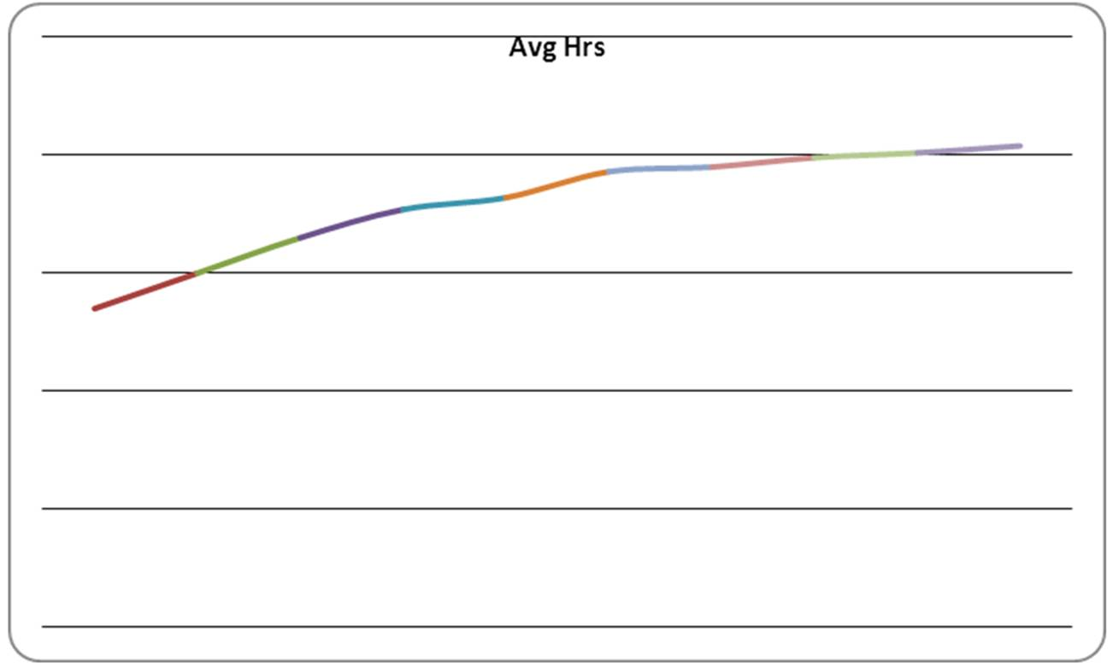  Hours spent on the Internet have increased over the 10 years but show a slight leveling off in the last 3 years.  Feedback: Displaying the average hours spent on Internet activities graphically results in a time series or runs plot. An increase over time in the amount of time can be observed through either the graph or data.

AACSB: Reflective Thinking
Blooms: Apply
Blooms: Understand
Difficulty: 2 Medium
Learning Objective: 01-04 Construct and interpret a time series (runs) plot.
Topic: Time Series Data

